Name: Christian Alvarez
Date: November 30, 2025
Class: IT2249
Unit: U8A1 Dimensional Array Java Console Application
Source Code
1. package u8a1_2dconsoleregisterforcourse;
2.
3. import java.util.Scanner;
4.
5. /**
6. * @author Christian
7. *
8. * Pseudocode:
9. * 1. Initialize 2D arrays for courses and validChoices
10. * 2. Display menu and get user choice
11. * 3. Validate choice against business rules
12. * 4. Store valid registration in validChoices array
13. * 5. Display current registrations
14. * 6. Repeat until user enters "N"
15. */
16. public class U8A1_2DConsoleRegisterForCourse {
18.
19. public static void main(String[] args) {
20. System.out.println("Welcome to Course Registration!");
21. System.out.println("You may register for up to 3 courses with a maximum of 9 credit hours total.");
22. System.out.println();
23.
24. Scanner input = new Scanner(System.in);
25.
26. // courses 2d array hold course code and their credit hours
27. String[][] courses = {
28. {"IT1006", "IT4782", "IT4789", "IT4079", "IT2230", "IT3345", "IT2249"},
29. {"6", "3", "3", "6", "3", "3", "6"}
30. };
31.
32. // validChoices 2d array holds valid number choices (as strings) selected by user
33. // and their corresponding courses
34. //e.g String[][] choices = { {"5", "IT2230"}, {"1", "IT1006"}, {"6", "IT3345"} };
35. String[][] validChoices = {
36. {"", ""},
37. {"", ""},
38. {"", ""}
39. };
40.
41. int choice;
42. int totalCredit = 0;
43. String yesOrNo = "";
45.
46. do {
47.
48. choice = getChoice(courses, input);
49.
50. switch (ValidateChoice(choice, validChoices, totalCredit, courses)) {
51. case -1:
52. System.out.println("**Invalid** - Your selection of " +
53. choice + " is not a recognized course.");
54. break;
55. case -2:
56. System.out.println("**Invalid** - You have already registerd for this " +
57. courses[0][choice-1] + " course.");
58. break;
59. case -3:
60. System.out.println("**Invalid** - You can not register for more than 9 credit hours.");
61. break;
62. case 0:
63. System.out.println("Registration Confirmed for course " +
64. courses[0][choice-1] );
65. totalCredit += Integer.parseInt(courses[1][choice-1]);
66. if (validChoices[0][0].equals("")) {
67. validChoices[0][0] = Integer.toString(choice);
68. validChoices[0][1] = courses[0][choice-1];
69. } else if (validChoices[1][0].equals("")) {
70. validChoices[1][0] = Integer.toString(choice);
71. validChoices[1][1] = courses[0][choice-1];
72. } else if (validChoices[2][0].equals("")) {
73. validChoices[2][0] = Integer.toString(choice);
74. validChoices[2][1] = courses[0][choice-1];
75. }
76. break;
77. }
78.
79. WriteCurrentRegistration(validChoices, totalCredit);
80.
81. // Check if user has reached maximum registrations or credits
82. if (!validChoices[2][0].equals("")) {
83. System.out.println("\nYou have registered for the maximum of 3 courses.");
84. System.out.println("Registration complete. Exiting program.");
85. break;
86. }
87.
88. // Check if user cannot register for any more courses due to credit limit
89. boolean canRegisterMore = false;
90. for (int i = 0; i < courses[0].length; i++) {
91. int courseCredits = Integer.parseInt(courses[1][i]);
92. if (totalCredit + courseCredits <= 9) {
93. // Check if not already registered
94. String checkChoice = Integer.toString(i + 1);
95. if (!checkChoice.equals(validChoices[0][0]) &&
96. !checkChoice.equals(validChoices[1][0]) &&
97. !checkChoice.equals(validChoices[2][0])) {
98. canRegisterMore = true;
99. break;
100. }
101. }
102. }
103.
104. if (!canRegisterMore && !validChoices[0][0].equals("")) {
105. System.out.println("\nYou cannot register for any additional courses without exceeding the 9 credit hour limit.");
106. System.out.println("Registration complete. Exiting program.");
107. break;
108. }
109.
110. System.out.print("\nDo you want to try again? (Y|N)? : ");
111.
112. yesOrNo = input.next().toUpperCase();
113.
114. } while (yesOrNo.equals("Y"));
115.
116. System.out.println("Thank you for registering with us");
117.
118. }
119.
120. //This method prints out the selection menu to the user in the form of
121. //[selection number]Course Code (Course Credit Hours)
122. //from the courses array one per line
123. //and then prompts the use to make a number selection
124. public static int getChoice(String[][] courses, Scanner input) {
125. System.out.println("Please type the number inside the [] to register for a course");
126. System.out.println("The number inside the () is the credit hours for the course");
127. for(int i = 0; i < courses[0].length; i++ )
128. System.out.println("[" + (i+1) + "]" + courses[0][i] + "(" + courses[1][i] + ")");
129. System.out.print("Enter your choice : ");
130.
131. try {
132. return input.nextInt();
133. } catch (Exception e) {
134. input.nextLine(); // Clear the invalid input
135. System.out.println("Invalid input. Please enter a number.");
136. return -1; // Return invalid choice
137. }
138. }
140.
141. //This method validates the user menu selection.
142. //against the given registration business rules
143. //it returns the following code based on the validation result
144. // -1 = invalid, unrecognized menu selection
145. // -2 = invalid, already registered for the course
146. // -3 = invalid, No more than 9 credit hours allowed
147. // 0 = menu selection is valid
148. public static int ValidateChoice(int choice, String[][] validChoices, int totalCredit, String[][] courses) {
149. String choiceAsString = Integer.toString(choice);
150. if (choice < 1 || choice > 7) {
151. return -1;
152. } else if (choiceAsString.equals(validChoices[0][0]) || choiceAsString.equals(validChoices[1][0]) || choiceAsString.equals(validChoices[2][0])) {
153. return -2;
154. } else if ( totalCredit + Integer.parseInt(courses[1][choice-1]) > 9) {
155. return -3;
156. }
157.
158. return 0;
159. }
161.
162. //This method prints the current list of registered courses thus far
163. //from the courses array separated by , and enclosed inside { }
164. //It also prints the total credit registered for thus far
165. public static void WriteCurrentRegistration(String[][] validChoices, int totalCredit) {
166.
167. if (validChoices[0][0].equals("")) {
168. System.out.println("Current course registration: { none } " );
169. } else if (validChoices[1][0].equals("")) {
170. System.out.println("Current course registration: { " + validChoices[0][1] + " }" );
171. } else if (validChoices[2][0].equals("")) {
172. System.out.println("Current course registration: { " + validChoices[0][1] +
173. ", " + validChoices[1][1] + " }");
174. } else {
175. System.out.println("Current course registration: { " + validChoices[0][1] +
176. ", " + validChoices[1][1] + ", " + validChoices[2][1] + " }");
177. }
178.
179. System.out.println("Current registration total credit = " + totalCredit);
180. }
182. }
Screenshots
Failing Test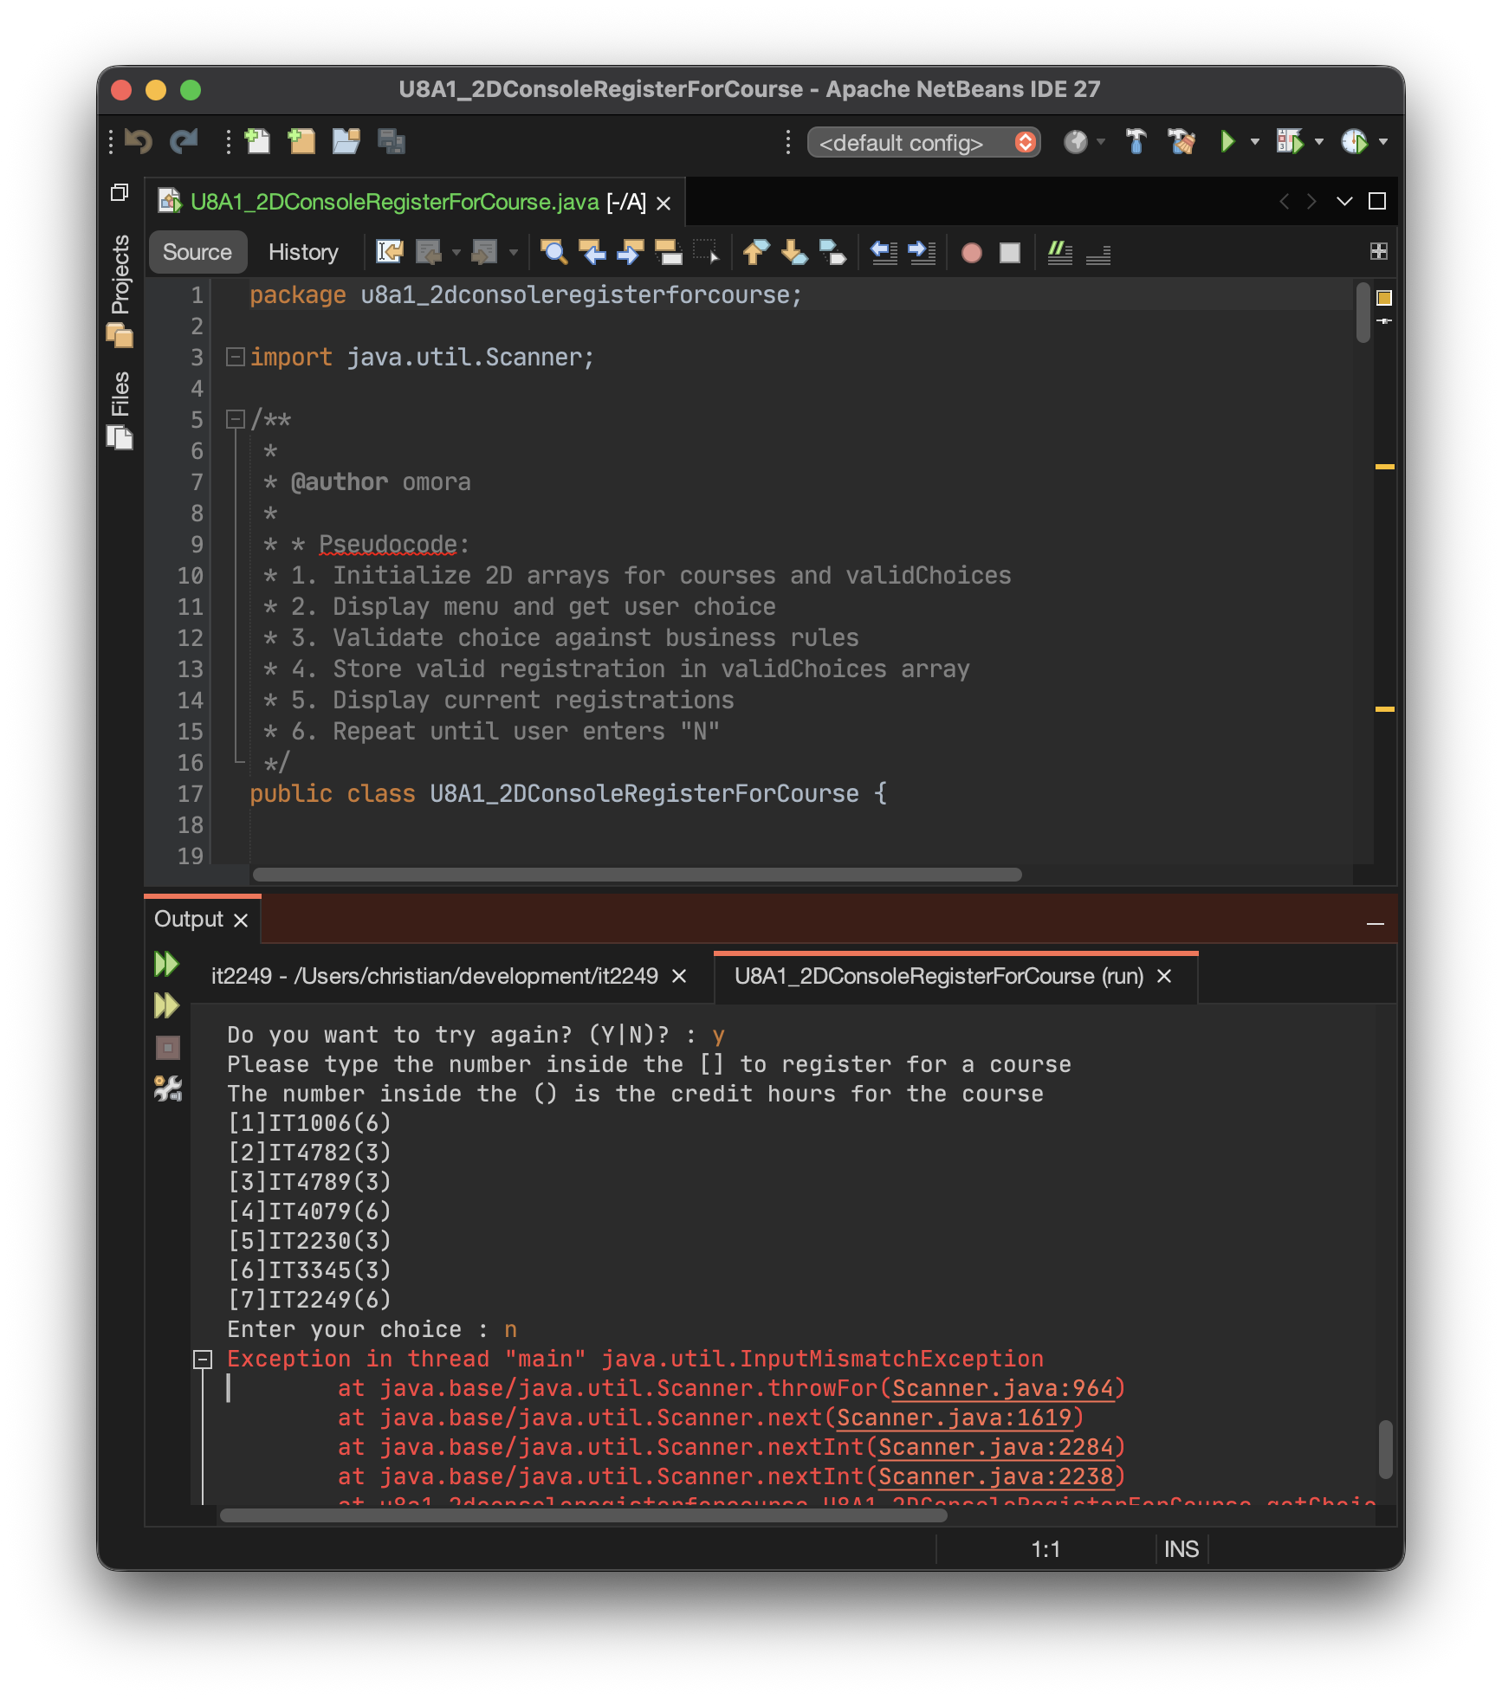

Passing Test
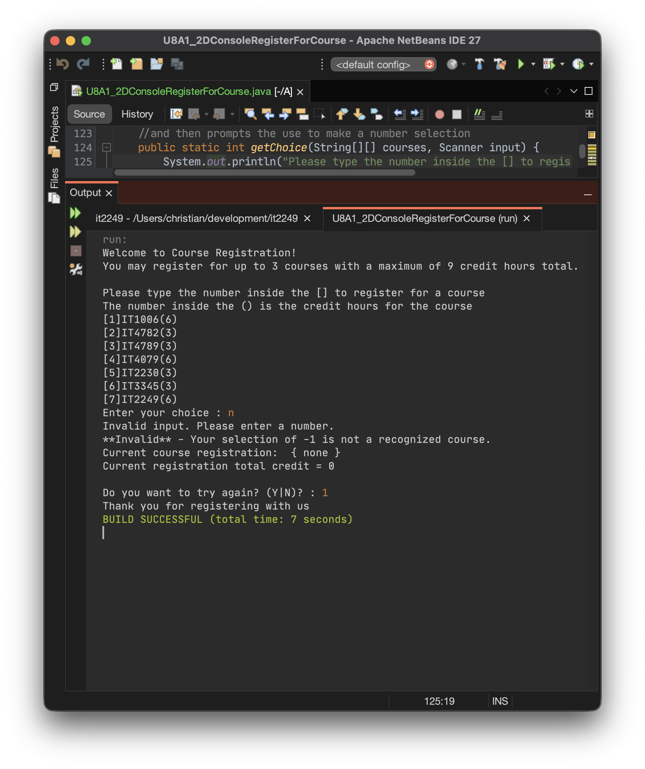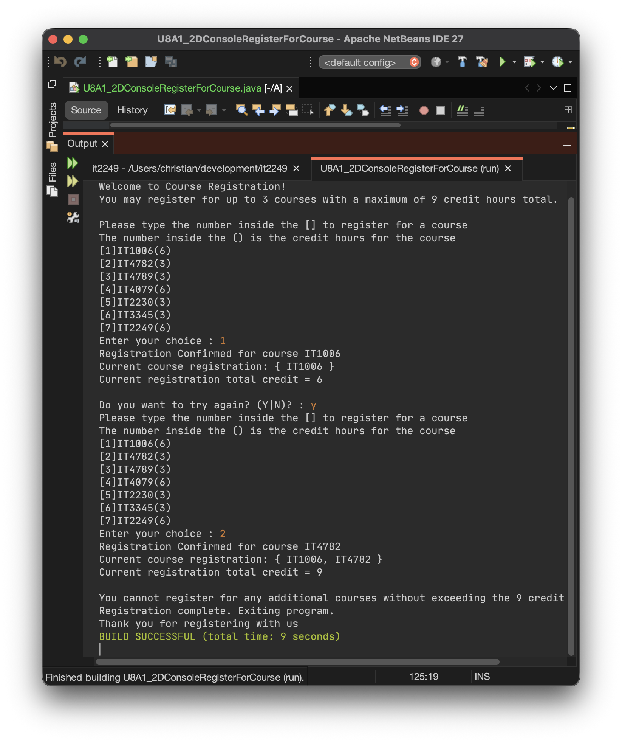

Explanation
Explanation
This assignment required debugging and fixing a Java console application that uses 2-dimensional arrays for a course registration system. The program allows users to register for up to three courses with a maximum of nine credit hours total while enforcing business rules such as preventing duplicate registrations and validating course selections.
I encountered some initial challenges with 2D arrays since I have not needed to use many of them in past projects. The concept of accessing elements with two indices took a moment to internalize, but once I understood how the courses array stored course codes in row 0 and credit hours in row 1, and how the validChoices array tracked registration data in a similar structure, the logic became clear. This was not too much of an issue to figure out overall.
The original code contained four main bugs. The first bug on line 56 was missing the second array index when assigning a course code to validChoices. The second bug on line 90 had an incomplete array access statement in the validation method. The third bug on line 104 used an undefined variable 'i' instead of the correct array index. The fourth bug on line 82 declared the courses parameter as a single-dimensional array instead of a two-dimensional array, causing a type mismatch. I fixed these syntax errors along with several missing brackets and parentheses in the conditional statements and loops throughout the code.
Beyond the required fixes, I identified a potential runtime error when users entered non-numeric input. The original code would crash with an InputMismatchException if someone typed a letter instead of a number. To handle this bug, I implemented a try-catch block in the getChoice method that catches exceptions, clears the invalid input from the Scanner buffer, displays an error message to the user, and returns -1 to trigger the invalid course error handling. This makes the program more robust and user-friendly.
For improved user experience, I added a welcome message at the start that clearly informs users they can register for up to three courses with a maximum of nine credit hours. I also implemented logic to automatically exit the program when users reach the three-course limit or when no remaining courses can be added without exceeding the credit limit. This prevents users from being stuck in a loop where they cannot register for anything but keep getting prompted to continue. These enhancements were added for fun to make the application feel more polished and professional.
Overall, this project was not too hard to work with once I understood the 2D array structure and identified the syntax errors. The debugging process reinforced my understanding of array indexing, method signatures, exception handling, and user input validation. Testing the program with various inputs confirmed that all bugs were successfully fixed and that the enhanced features worked as intended.

